## EC2 Volumes

## EC2 Block-Based Virtual Disks

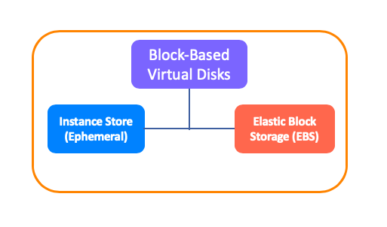

* Volume is a durable storage device that you can attach to instances. It is a location in which the associated machine stores its data or loads its applications.
* AWS serves 2 basic volume options for costumers in the Block-Based Storage category. These are Instance Store (Ephemeral) and Elastic Block Storage (EBS).

### Virtualization in EC2

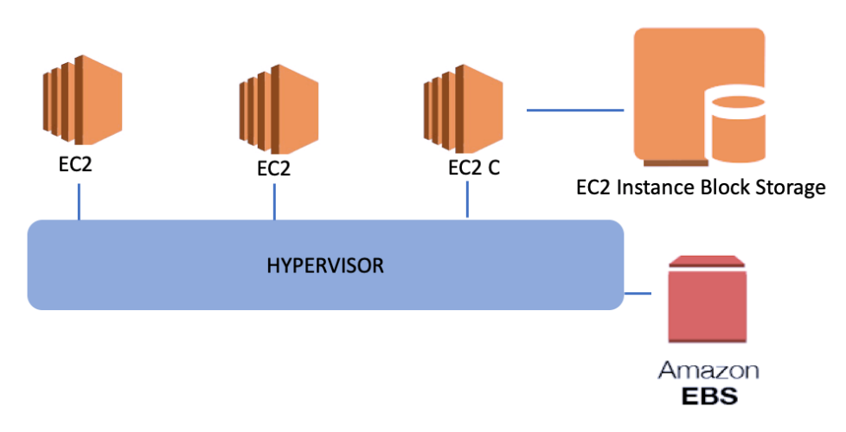

* In the virtualization environment, we have one physical server and a virtualization software on it, as seen in the figure above.
* We call this driver and software layer as a **Hypervisor**. The hypervisor is a system that ensures that all information within its body can be accessed by all connected machines or storage devices.
* The systems connected **directly to the hypervisor** and accessible to each machine associated with hypervisor we mentioned above is called EBS, **Elastic Block Storage**, in the AWS.
* Thus, if one of the physical servers fails, the virtual machine configurations running on it pass to the other physical server and continue to operate without interruption.
* But, instead of being connected directly to hypervisor, **Instance Block Storage** is **connected to only the related server** on which the virtual machine is running.

### Instance Block Storage (Ephemeral)

* The storage method that uses disks directly connected to the physical server on which the virtual machine is running. It may have SSD or magnetic HDD hard disk.
* The **advantage** of this model is that it provides high access speed and very low latency because it is directly on the physical server to which the virtual machine is connected.
* The **disadvantage** is that if the virtual machine shuts down in some way, all data here is lost. If something happens to the underlying physical machine or you turn off the virtual machine, the data on these disks cannot be accessed.

### EBS (Elastic Block Storage)

* EBS is the storage solution that can be attached to a virtual machine and can be installed in an operating system/application.
* EBS also provides a 99.999% accessibility guarantee and replicates data to multiple physical devices within the same AZ, including SSD or HDD based disk infrastructures.
* If you create a Windows or Linux EC2 instance EBS volume can be attached as Root device of volume automatically.Top of Form

### EBS Volume Types

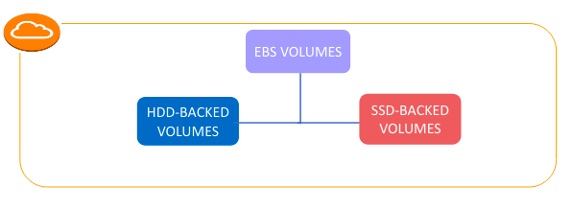

* **Solid state drives (SSD):** Optimized for transactional workloads involving frequent read/write operations with small I/O size, where the dominant performance attribute is IOPS.
* **Hard disk drives (HDD):** Optimized for large streaming workloads where the dominant performance attribute is throughput.

### IOPS and Throughput

* IOPS stands for **I**nput/Output **O**perations **P**er **S**econd.
* It is a common performance measurement used to test computer storage devices like HDD or SSD etc.
* IOPS is a value that specifies how many reads and writes can be made to a disk per second.
* **Throughput** is the value that specifies how many MB of data transfer per second is allowed to a storage system.
* While IOPS is related to the functional **speed** of the disk, Throughput is related to processing **capacity**.
* Throughput can be affected by IOPS, packet size and also network protocol.

## EC2 Volumes

### SSD Type EBS

### HDD Type EBS

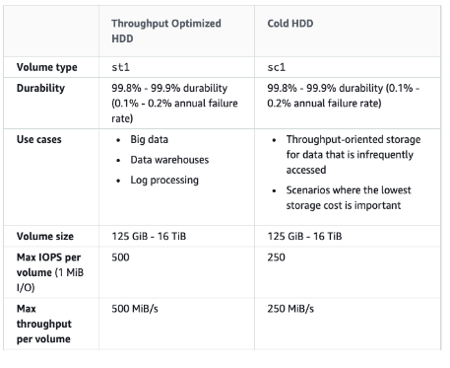

## Amazon Machine Image (AMI)

## AMI is a virtual image used to create a virtual machine within an EC2 instance.

## It is a virtual machine template containing predefined operating system and application files.

## All AMI provides a template for the root volume of an instance. You can copy the AMI and create another instance also.

### AMI Types

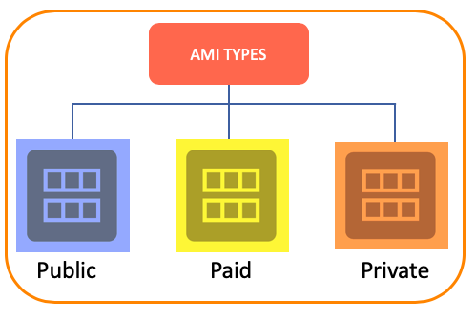

## **Public:**

## Public Shared Community AMIs and the AMIs managed by the Amazon itself.

## This package ****covers common server features****.

## **Paid:**

## Ready-made packages **created by various companies or independent developers**.

## Including various applications as well as the operating system.

## **Private:**

## We can create and manage with AWS Marketplace and Private Image BuildService.

## Snapshot

* Snapshot is the name of the method that allows us to take a current copy of an EBS disk.
* AWS stores the snapshots in the **S3**. But you can reach snapshots from the AWS Management Console.

## Purpose of Snapshot

## 

* The snapshots are used for the purpose of **Backup** because it allows you to save the current copy of that disk to a location.
* We can take a snapshot and then **Create AMI**. We can create a server and make all the settings on it, take a snapshot of it, then create an AMI and make a copy of the same machine.
* We can **Create Volume** from snapshots and connect it to other systems for use.

### Options of Creating a Snapshot

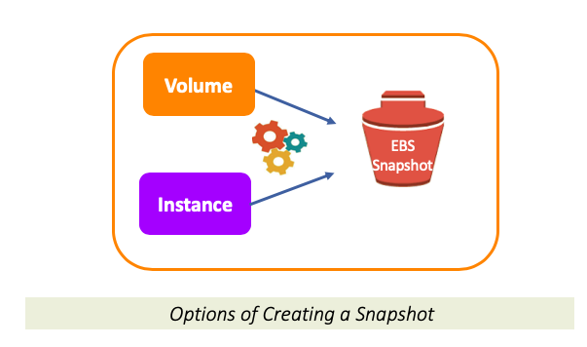

## When creating a snapshot, we have 2 options to use as a source. These are ****Volume**** and ****Instance****.

### Creating a Snapshot for a new AMI

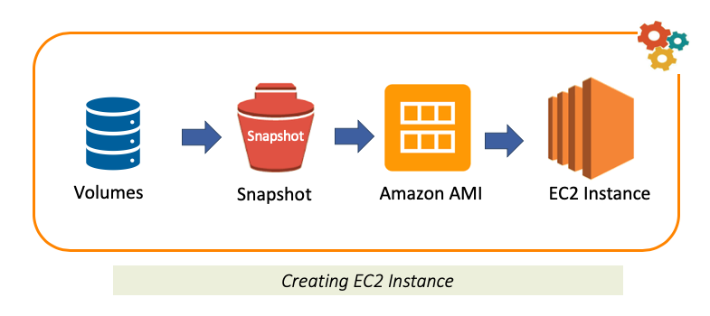

### Copying a Snapshot (A Way to Encrypt Unencrypted Root Device)

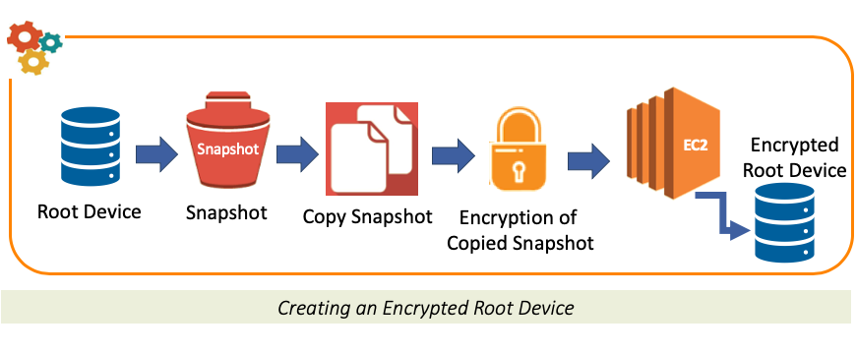

Root device (volume) cannot be encrypted after creation, but you can encrypt the root device (root volume) which is unencrypted via a **Copied Snapshot**:

Bottom of Form